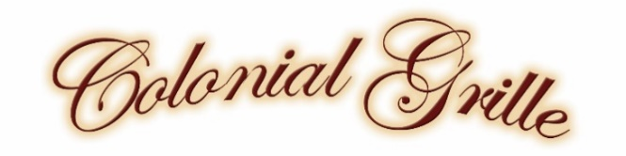
St. Patty’s Weekend Chef Specials
Starters
Soup Du Jour $5 cup / $7 bowl

Chicken Noodle
Guinness Beef Stew $10
Served in a mashed potato bowl

Entrée Specials

Beer Battered Fish & Chips $22
Fried Haddock | Handcut Chips | Slaw

Corned Beef & Cabbage $22
Slow Cooked Corned Beef | Irish Style Cabbage

Guinness Pot Pie $20
Roasted Prime Rib | Savory Guinness Stew | Mashed Potatoes

Shepherd’s Pie $18
Beef | Peas | Corn | Mashed Potatoes

Dessert Special

Sticky Toffee Cake $8

Beverage Specials

Irish Buck $10
Jameson Irish Whiskey | Lime | Ginger Ale

Irish Maid $11
Irish Whiskey | St. Germain Elderflower | Lemon | Simple

Lunch / Dinner Hours
Sunday thru Thursday 4pm – 9pm / Friday & Saturday Noon - 10pm
Breakfast Saturday & Sunday 8am – 11am

Online Reservations are available through RESY.com
Link is located on our website

Consuming raw or undercooked eggs, seafood or meat may increase your risk of foodborne illness.
Please inform your server of any allergies before ordering.

